

**BANGLADESH UNIVERSITY OF BUSINESS AND TECHNOLOGY (BUBT)**

**Department of Computer Science and Engineering**

Rupnagar, Mirpur-2, Dhaka-1216, Bangladesh

Phone: PABX-9024266, 9024277, 9015397, 9020132-4, Fax: 9024399

E-mail: info@bubt.edu.bd, Website: www.bubt.edu.bd

**EXAMINATION SCRIPT**

(To be filled up by class teacher) (This part is to be filled up by students)

|  |  |  |  |  |
| --- | --- | --- | --- | --- |
| **Question No.** | **Mark Obtained** |  | **Name:** | **Md. Zobayer Hasan Nayem** |
|  |  |  | **Student ID:** | **19202103274** |
|  |  |  | **Intake - Section:** | **44-7** |
|  |  |  | **Program:** | **B.Sc. in CSE** |
|  |  |  | **Course code:** | **CSE 121** |
|  |  |  | **Course title:** | **Computer Science and Engineering** |
|  |  |  | **Trimester:** | **Summer 2020** |
|  |  |  | **Exam type:** | **Final Exam** |
|  |  |  | **Date:** | **25 November, 2020** |
| Total Mark |  |  | **Question option:** |  |

Ans to the que no:01-(a)

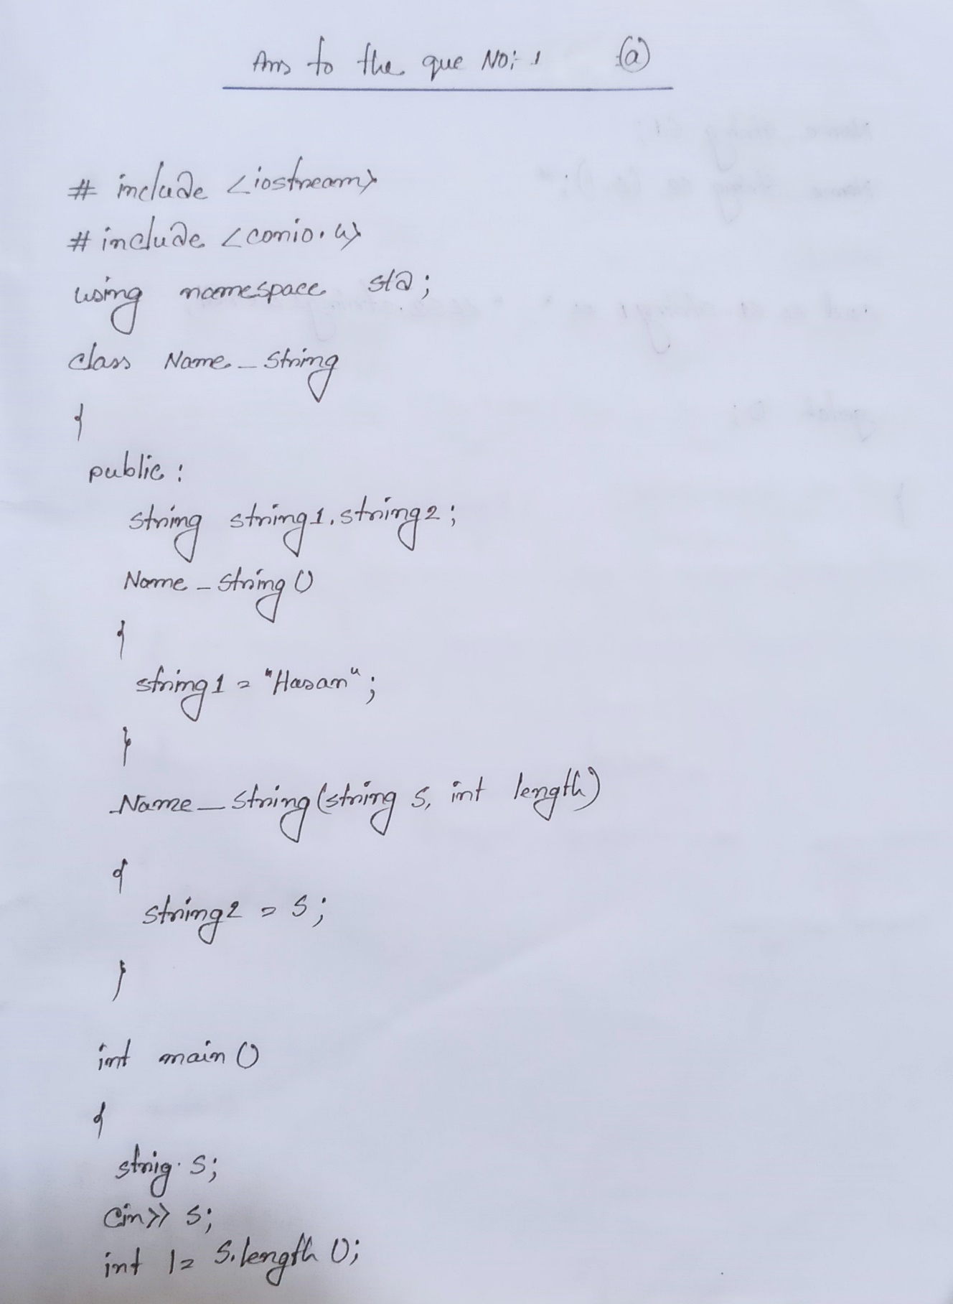

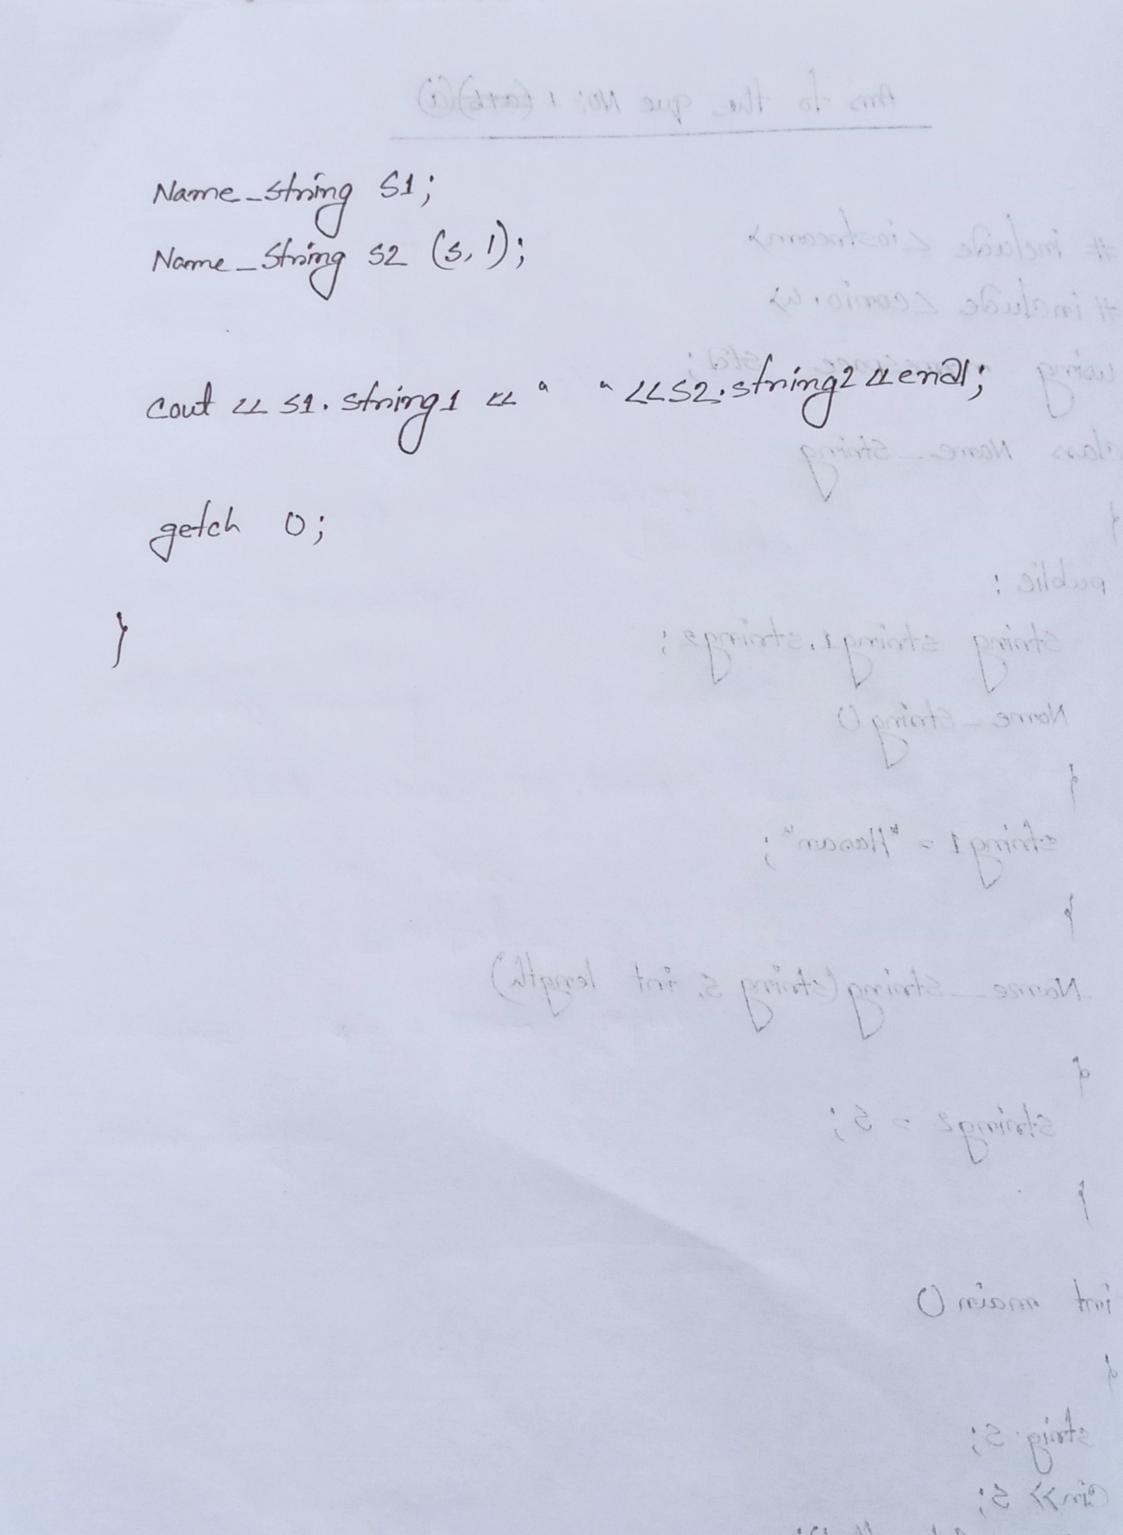

Ans to the Que no : 01-(b)

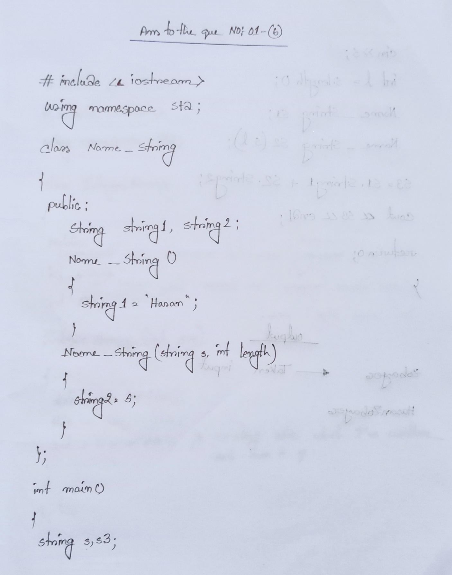

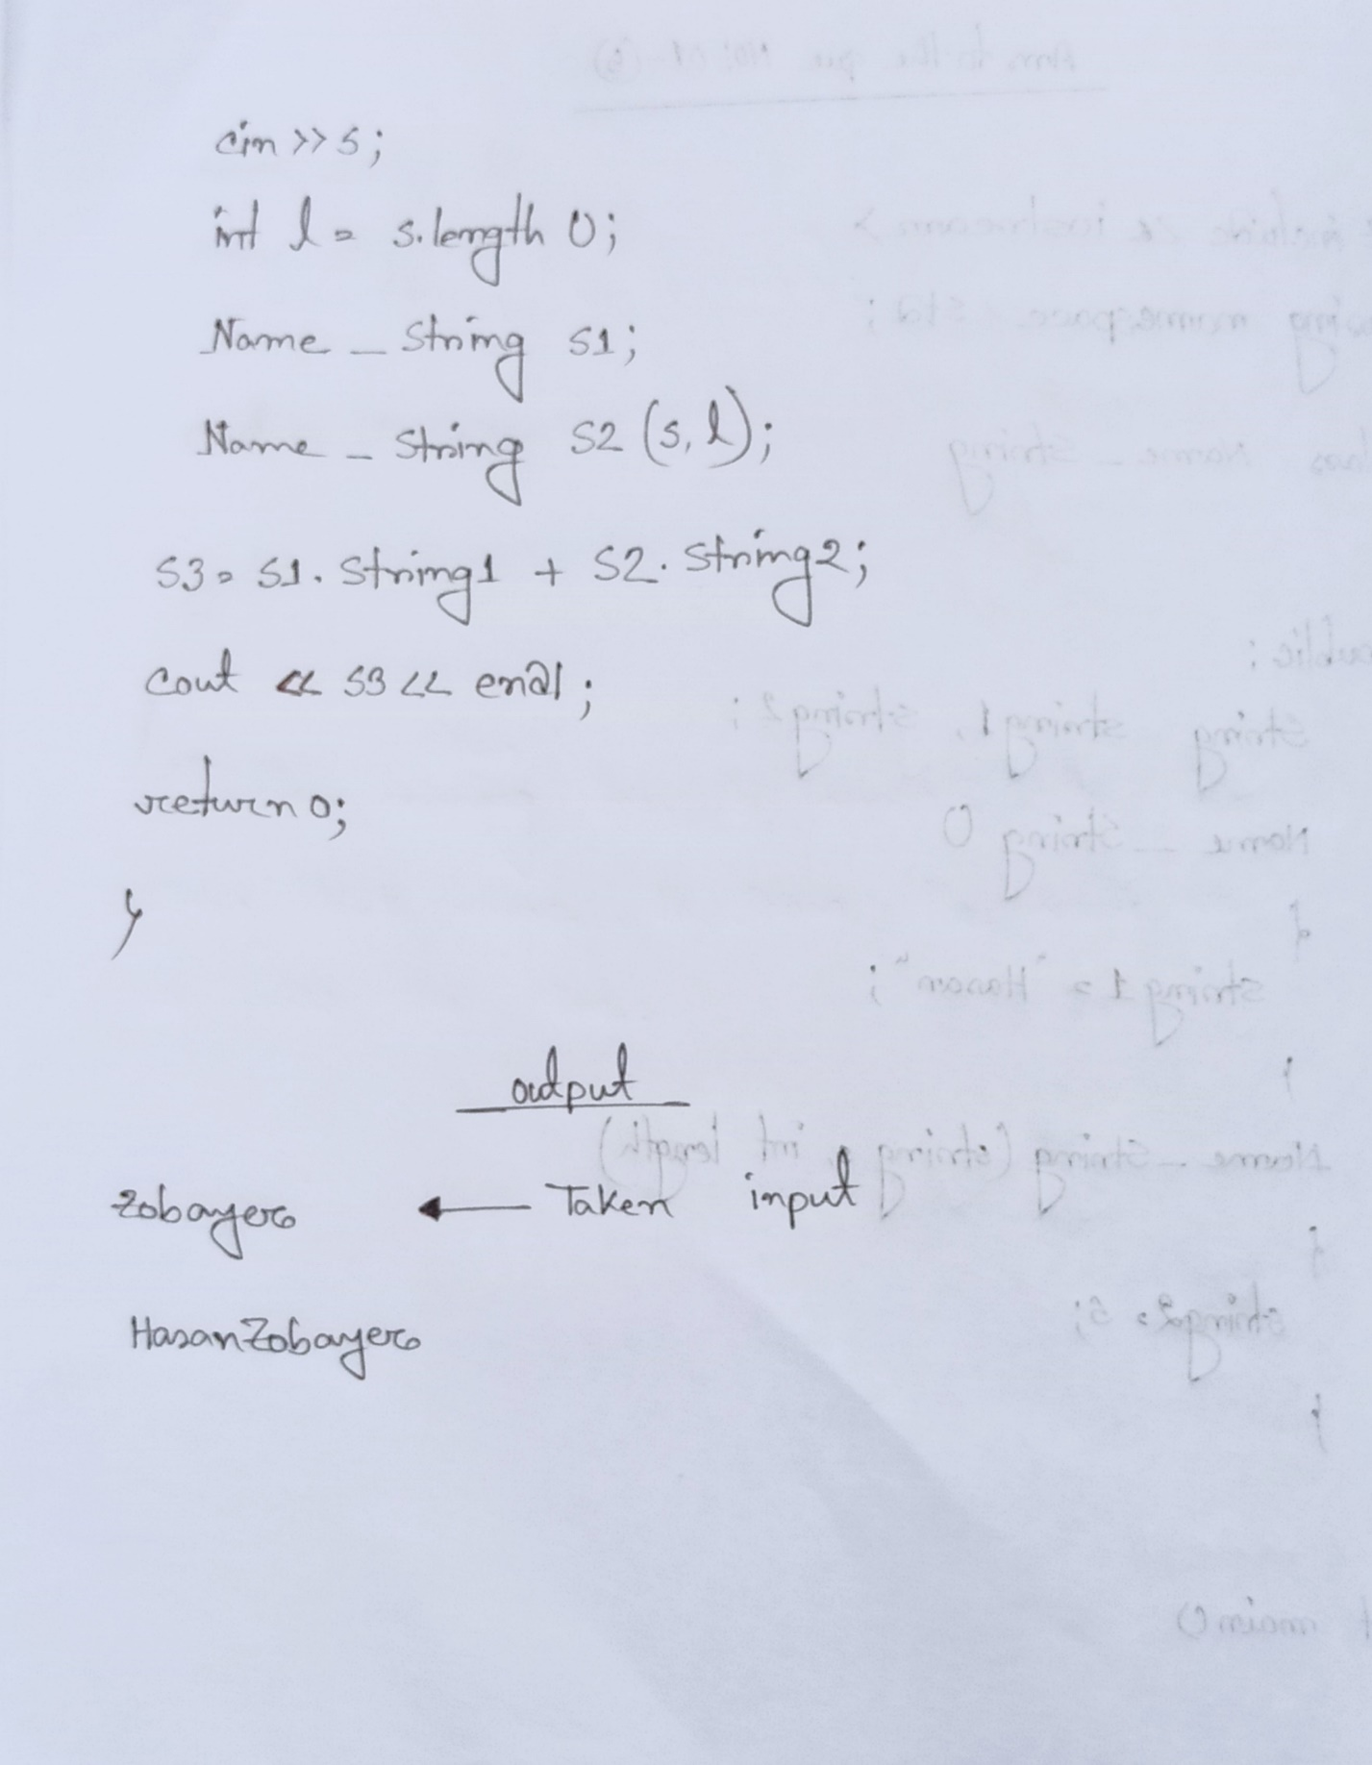

Ans To The Que 02(a)

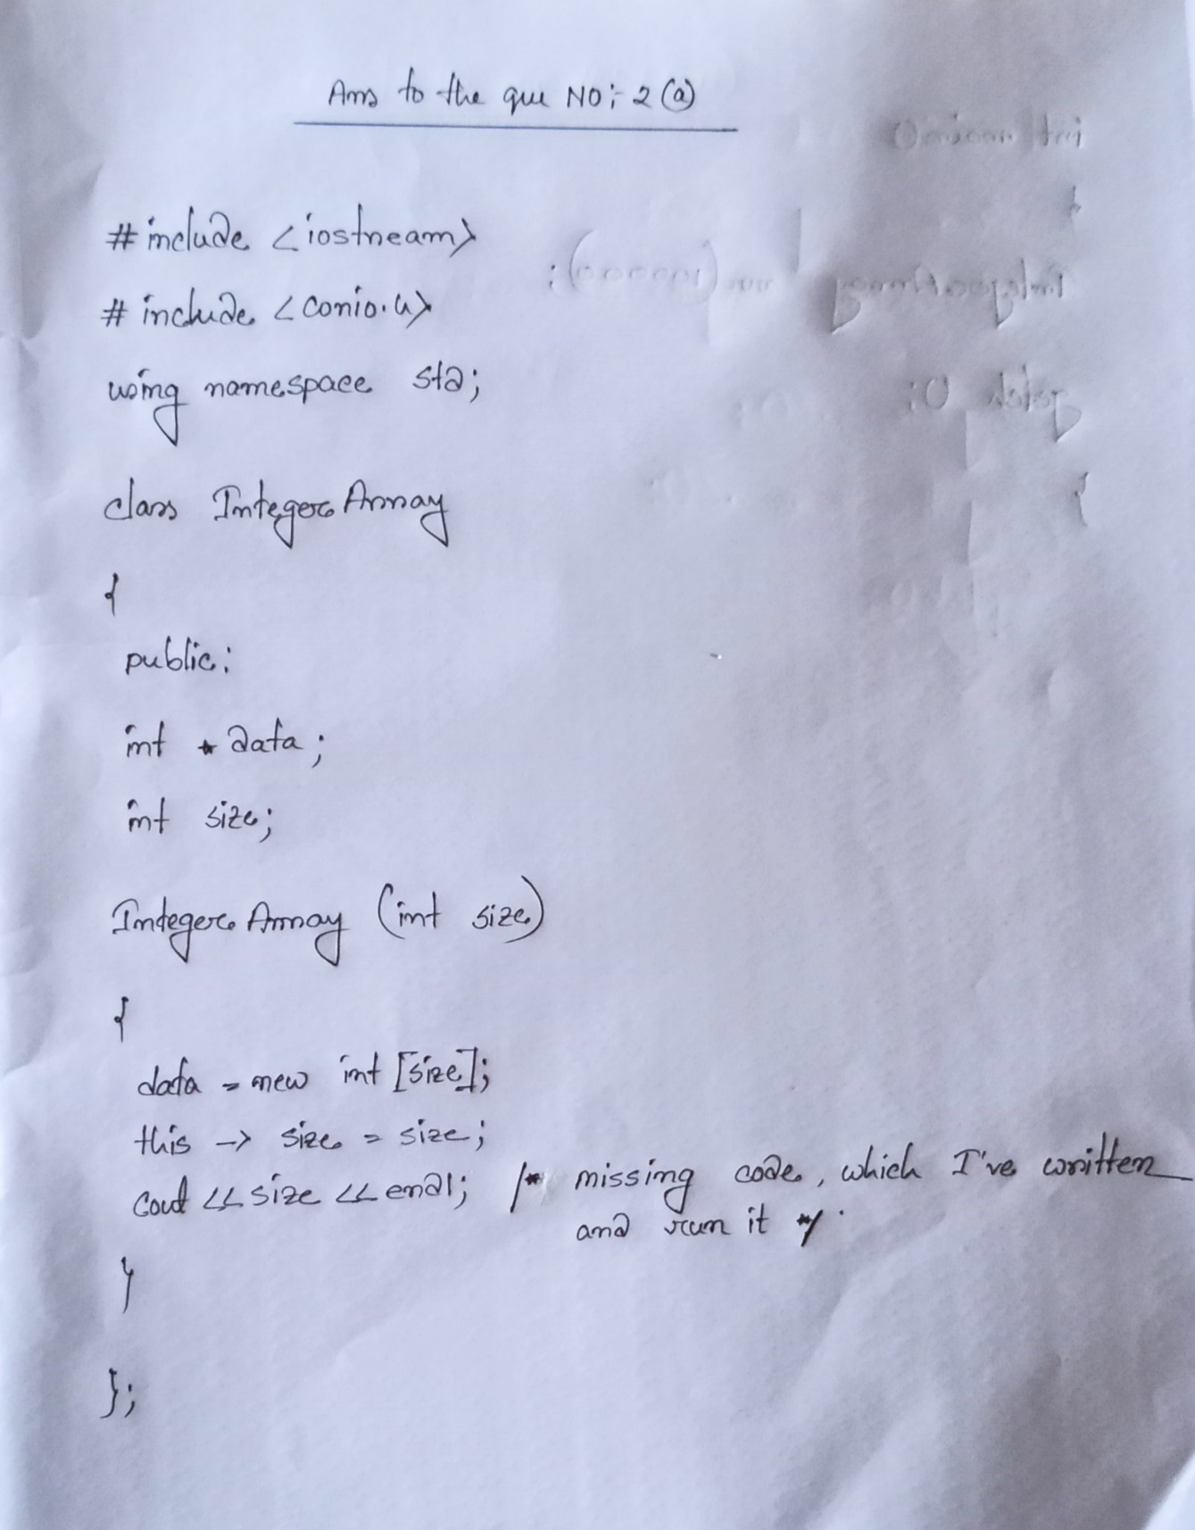

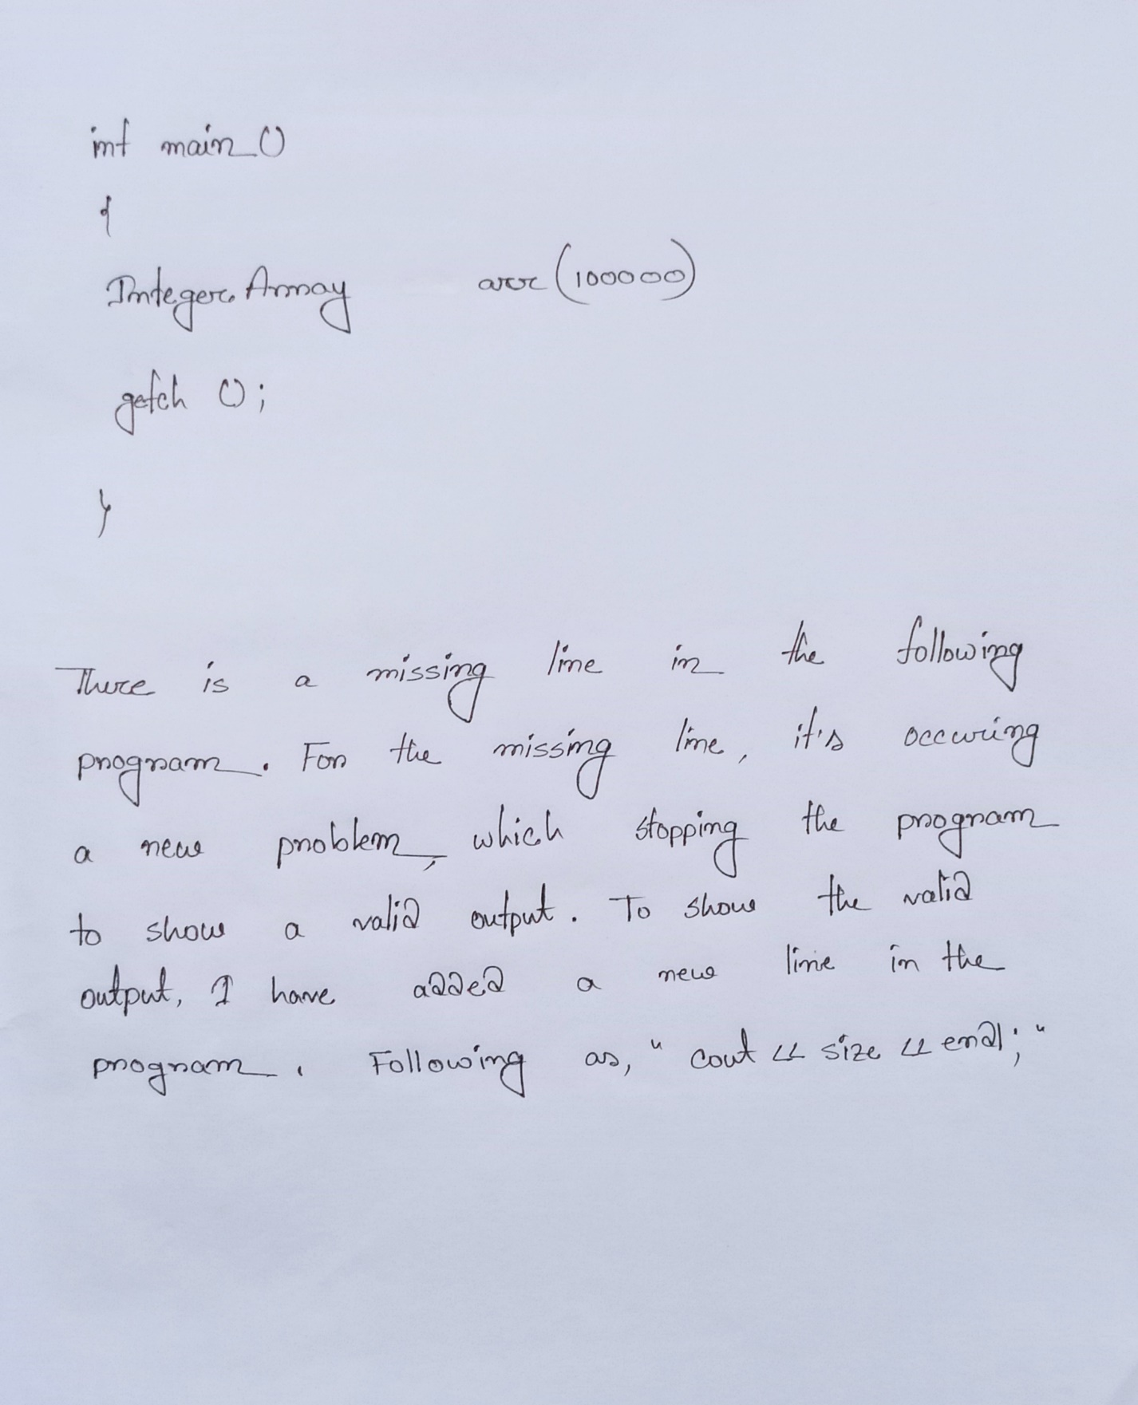

Ans To The Question-2(b)

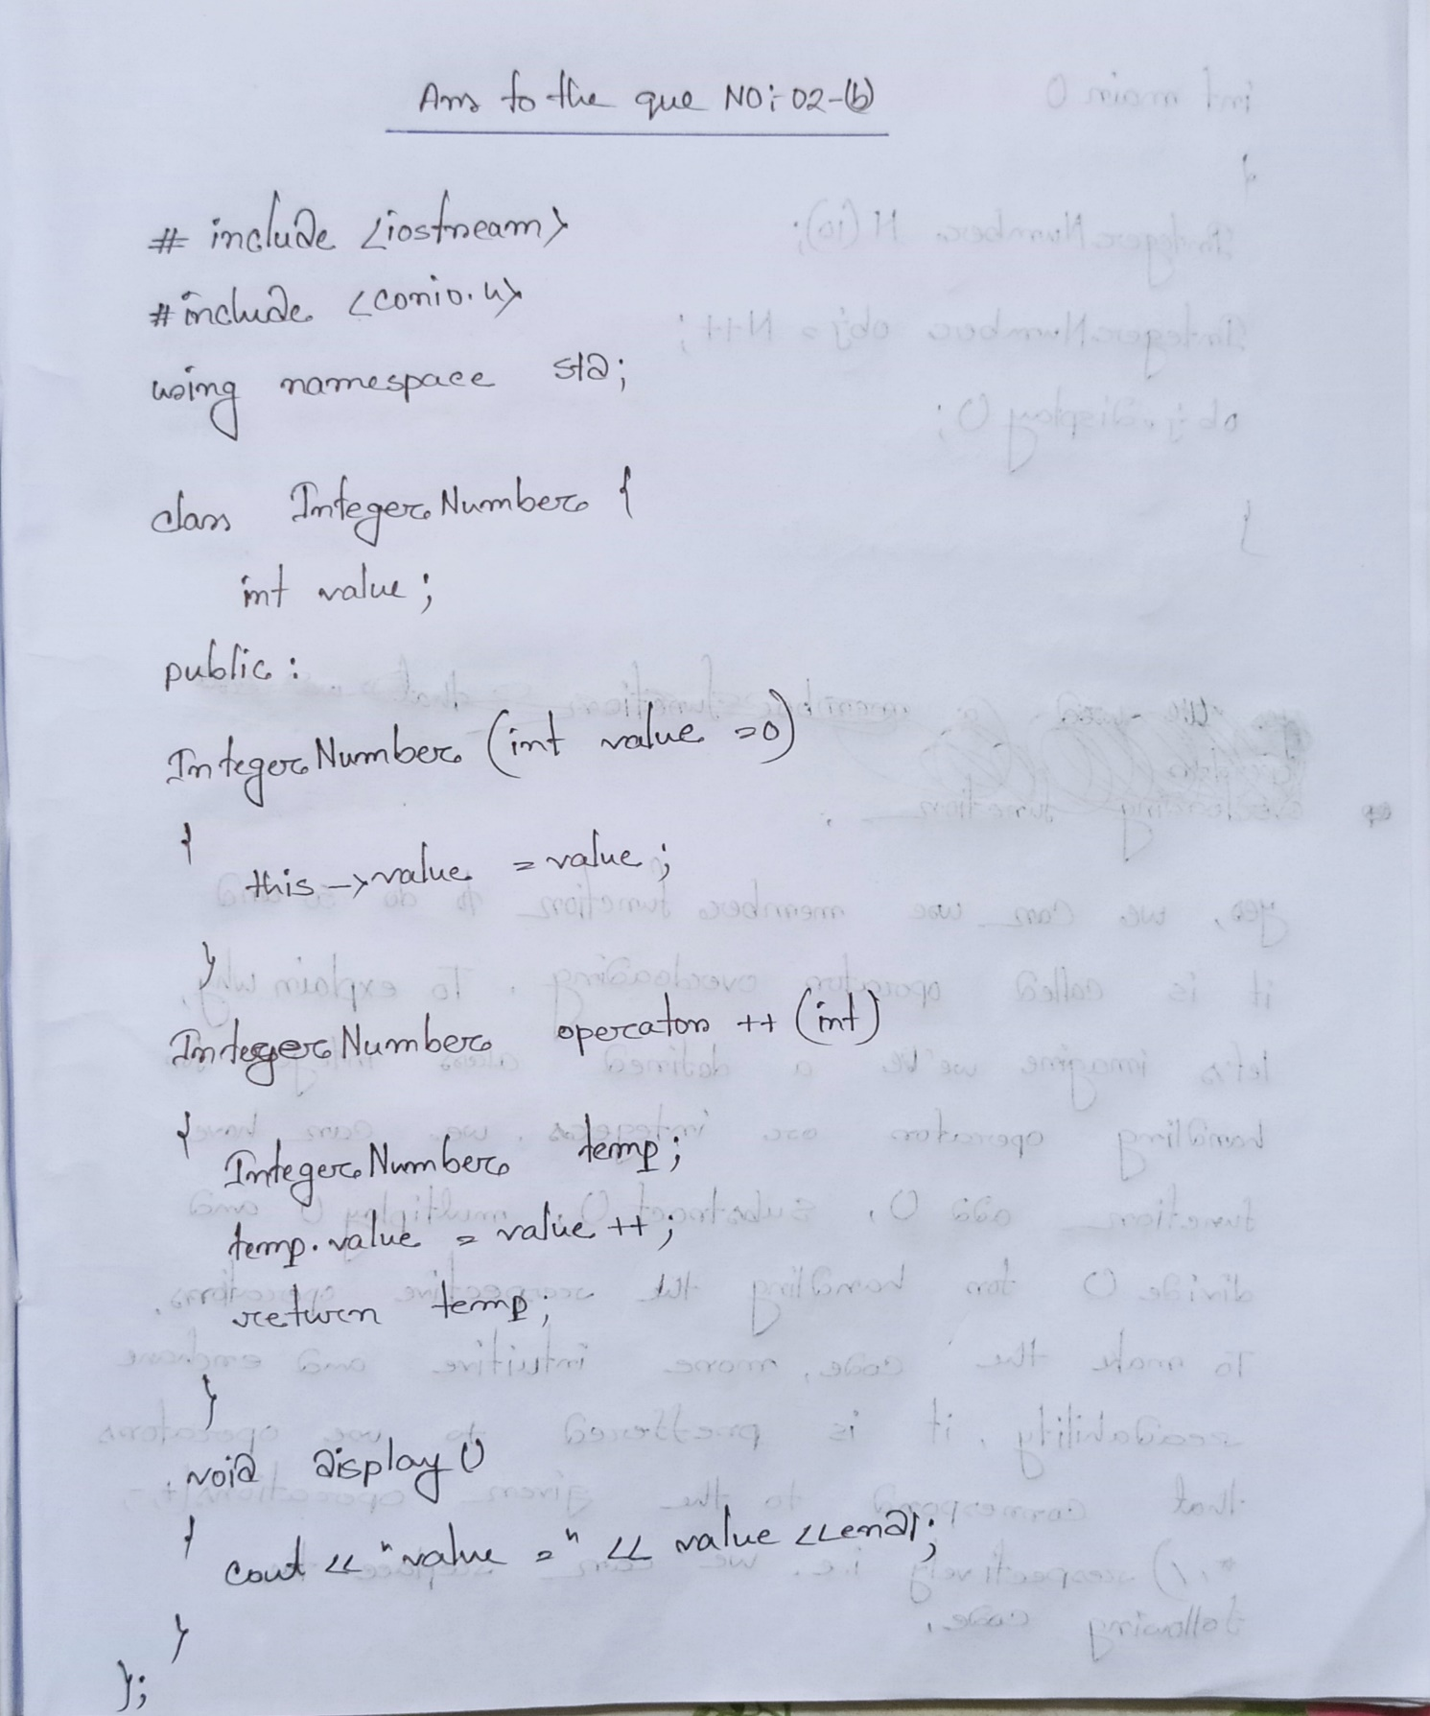

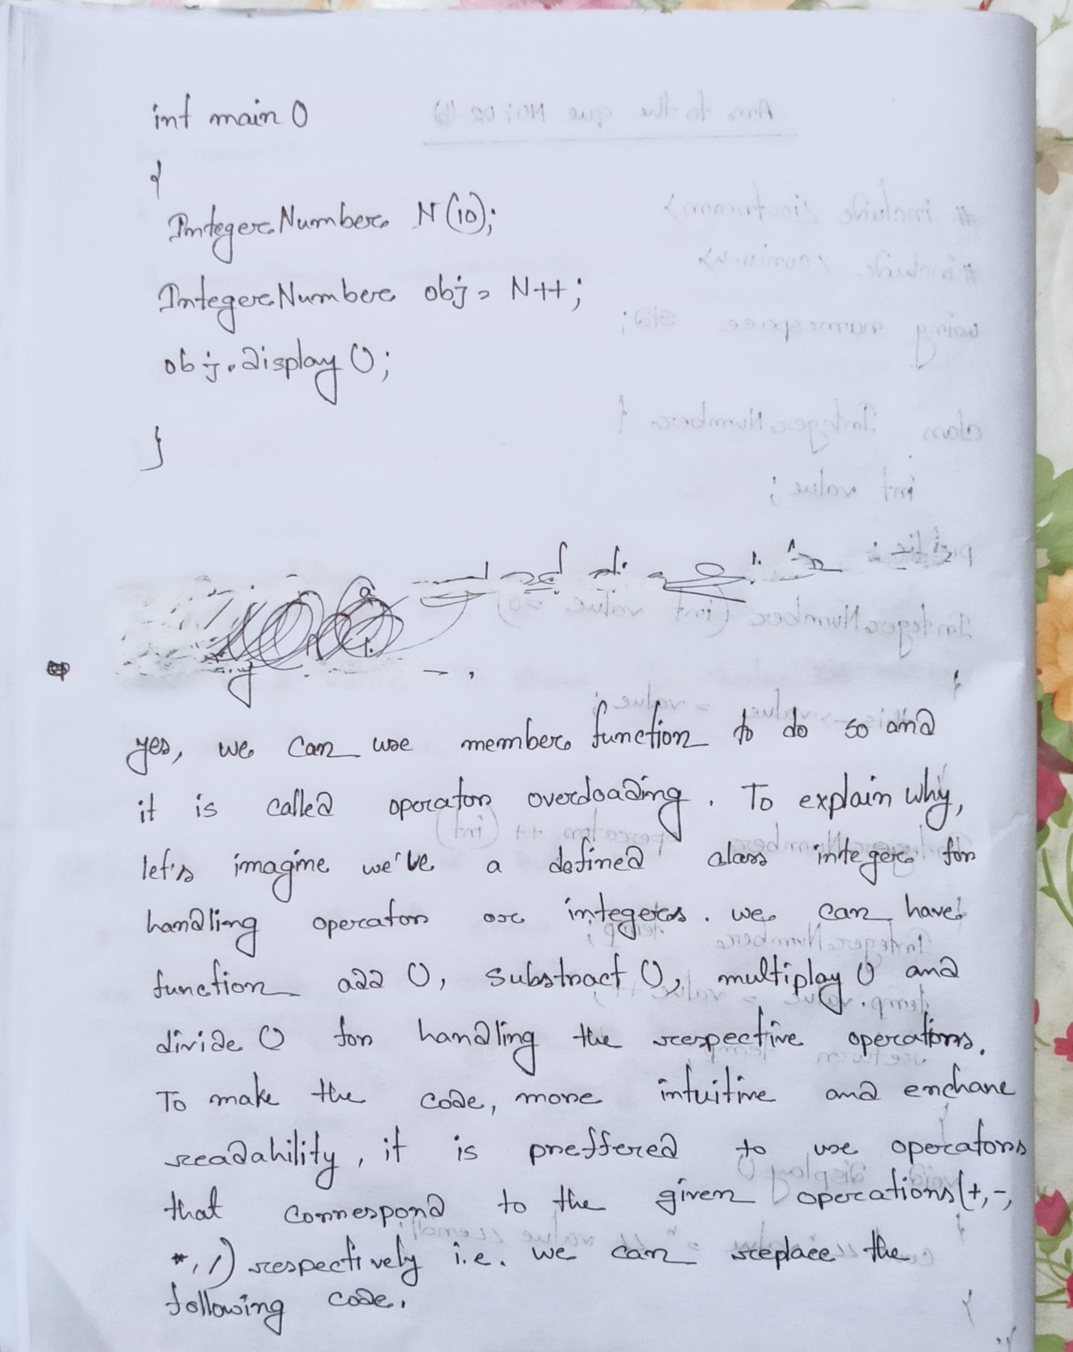

Ans To The Que No : 03-(a)

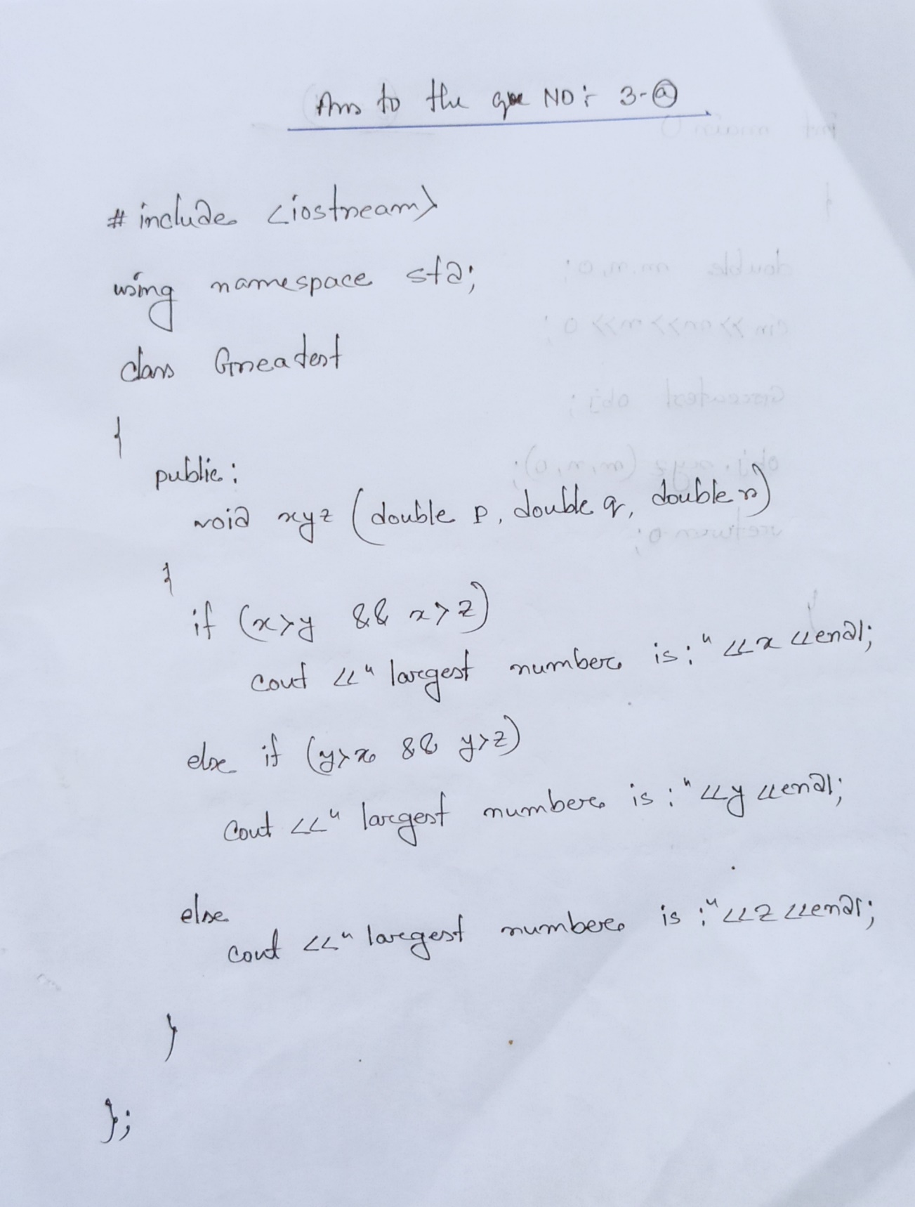

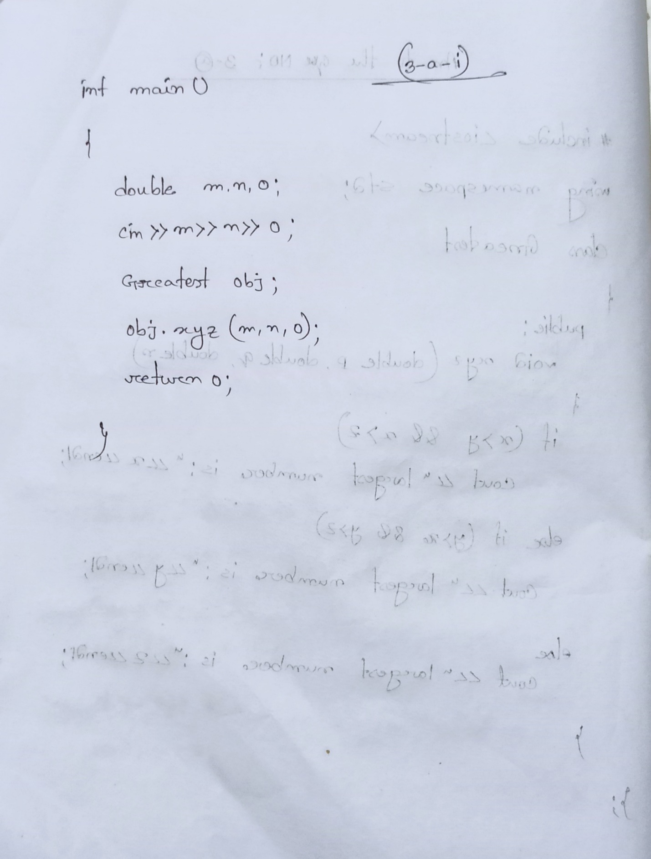

Ans to The Que No ; 03-(b)

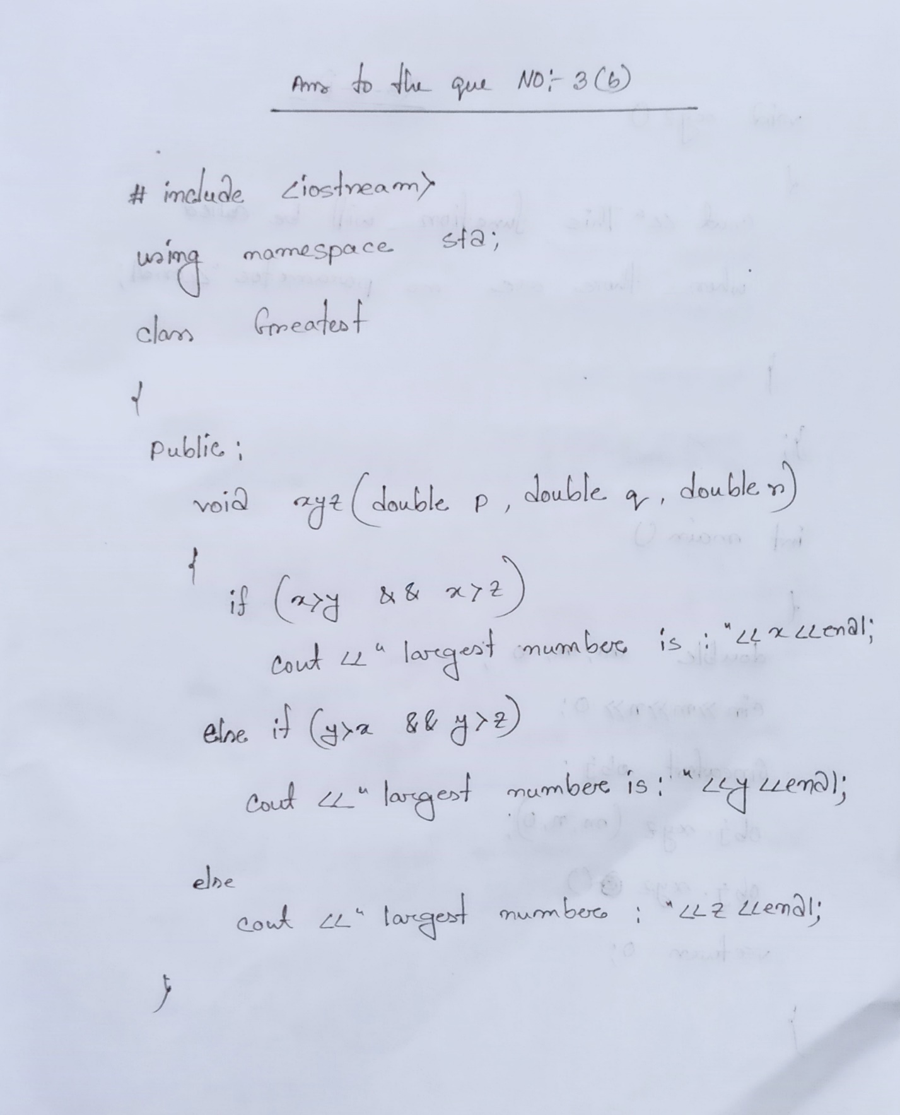

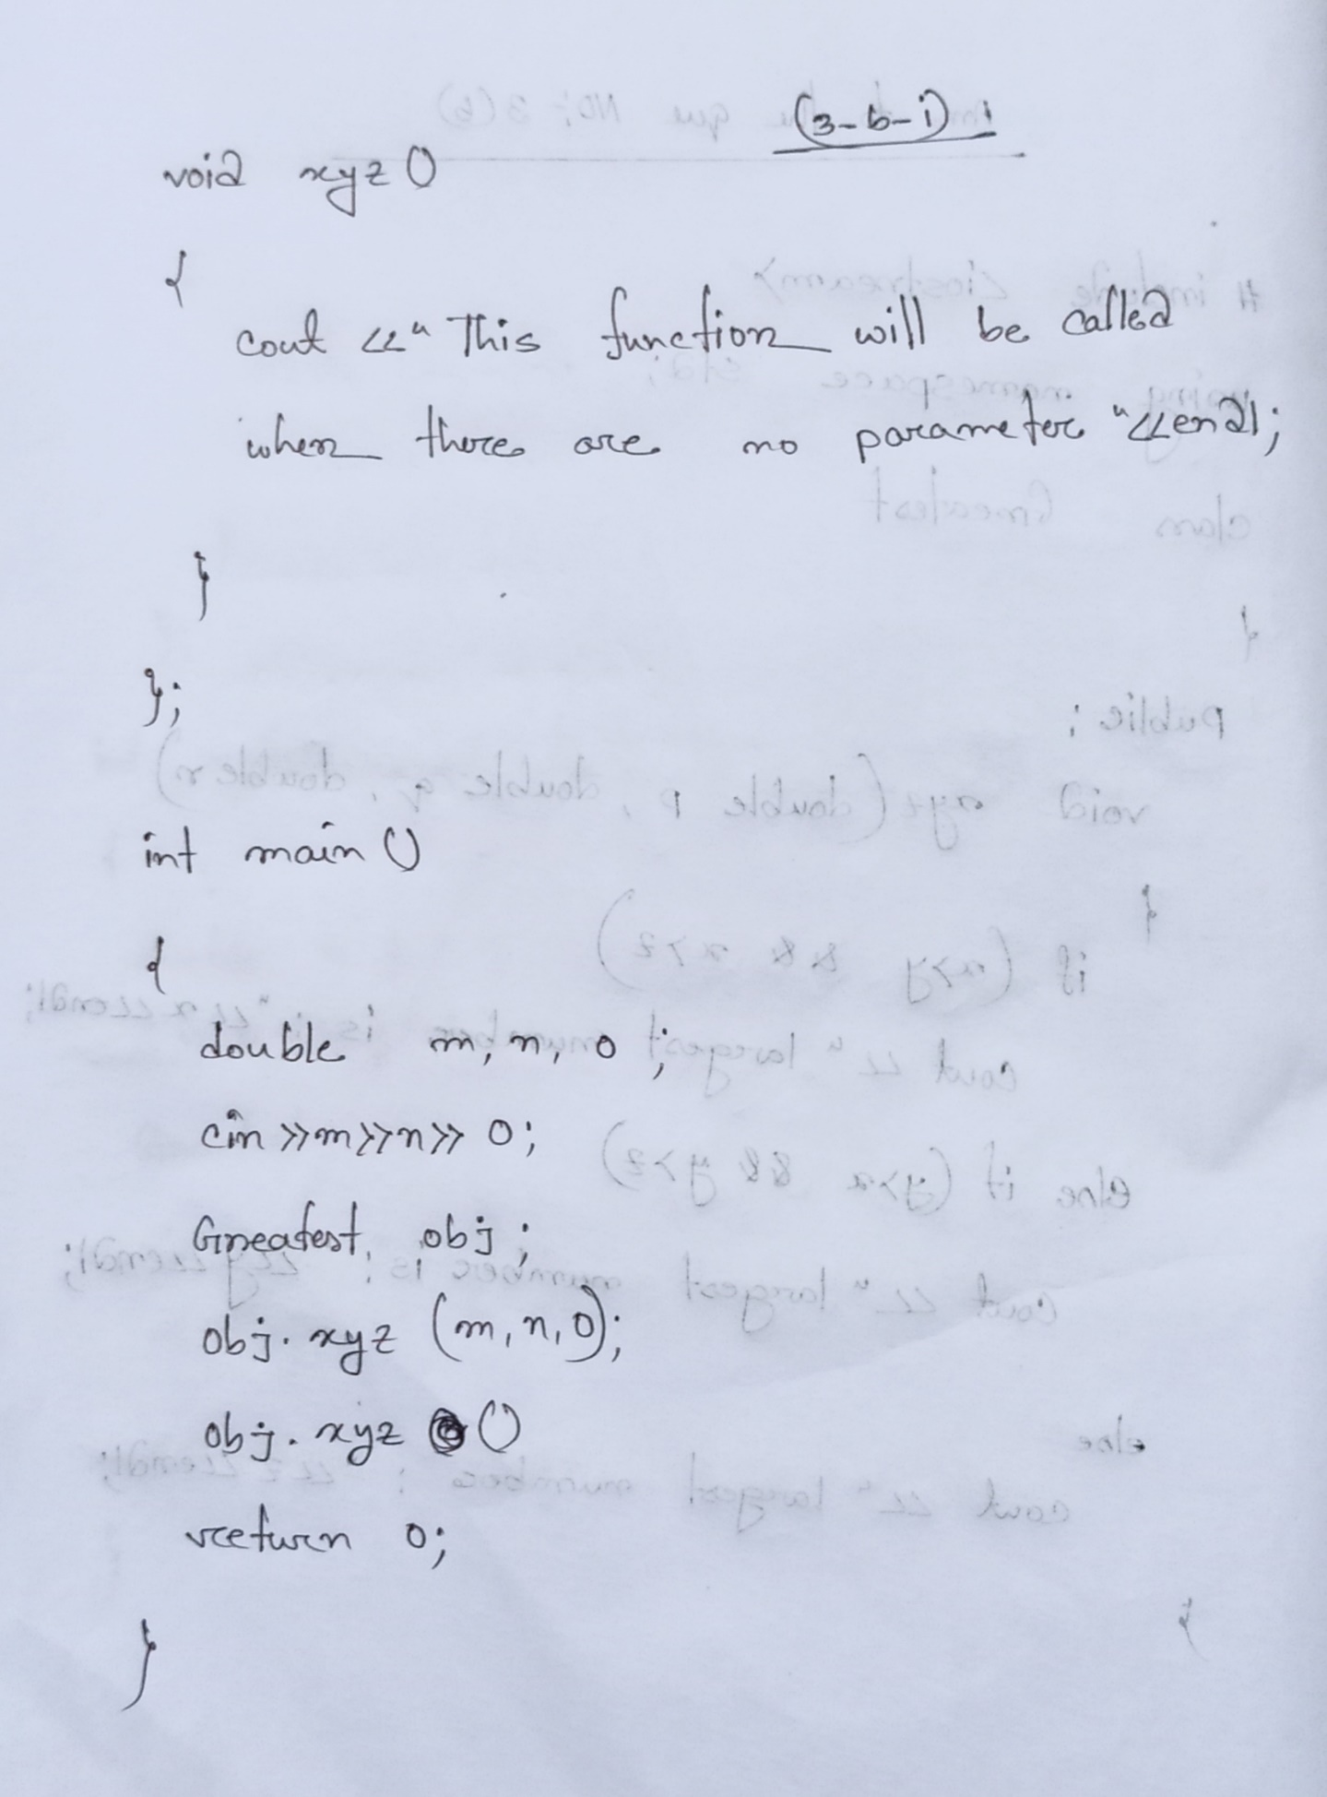 Ans To The Que No 04-(a)

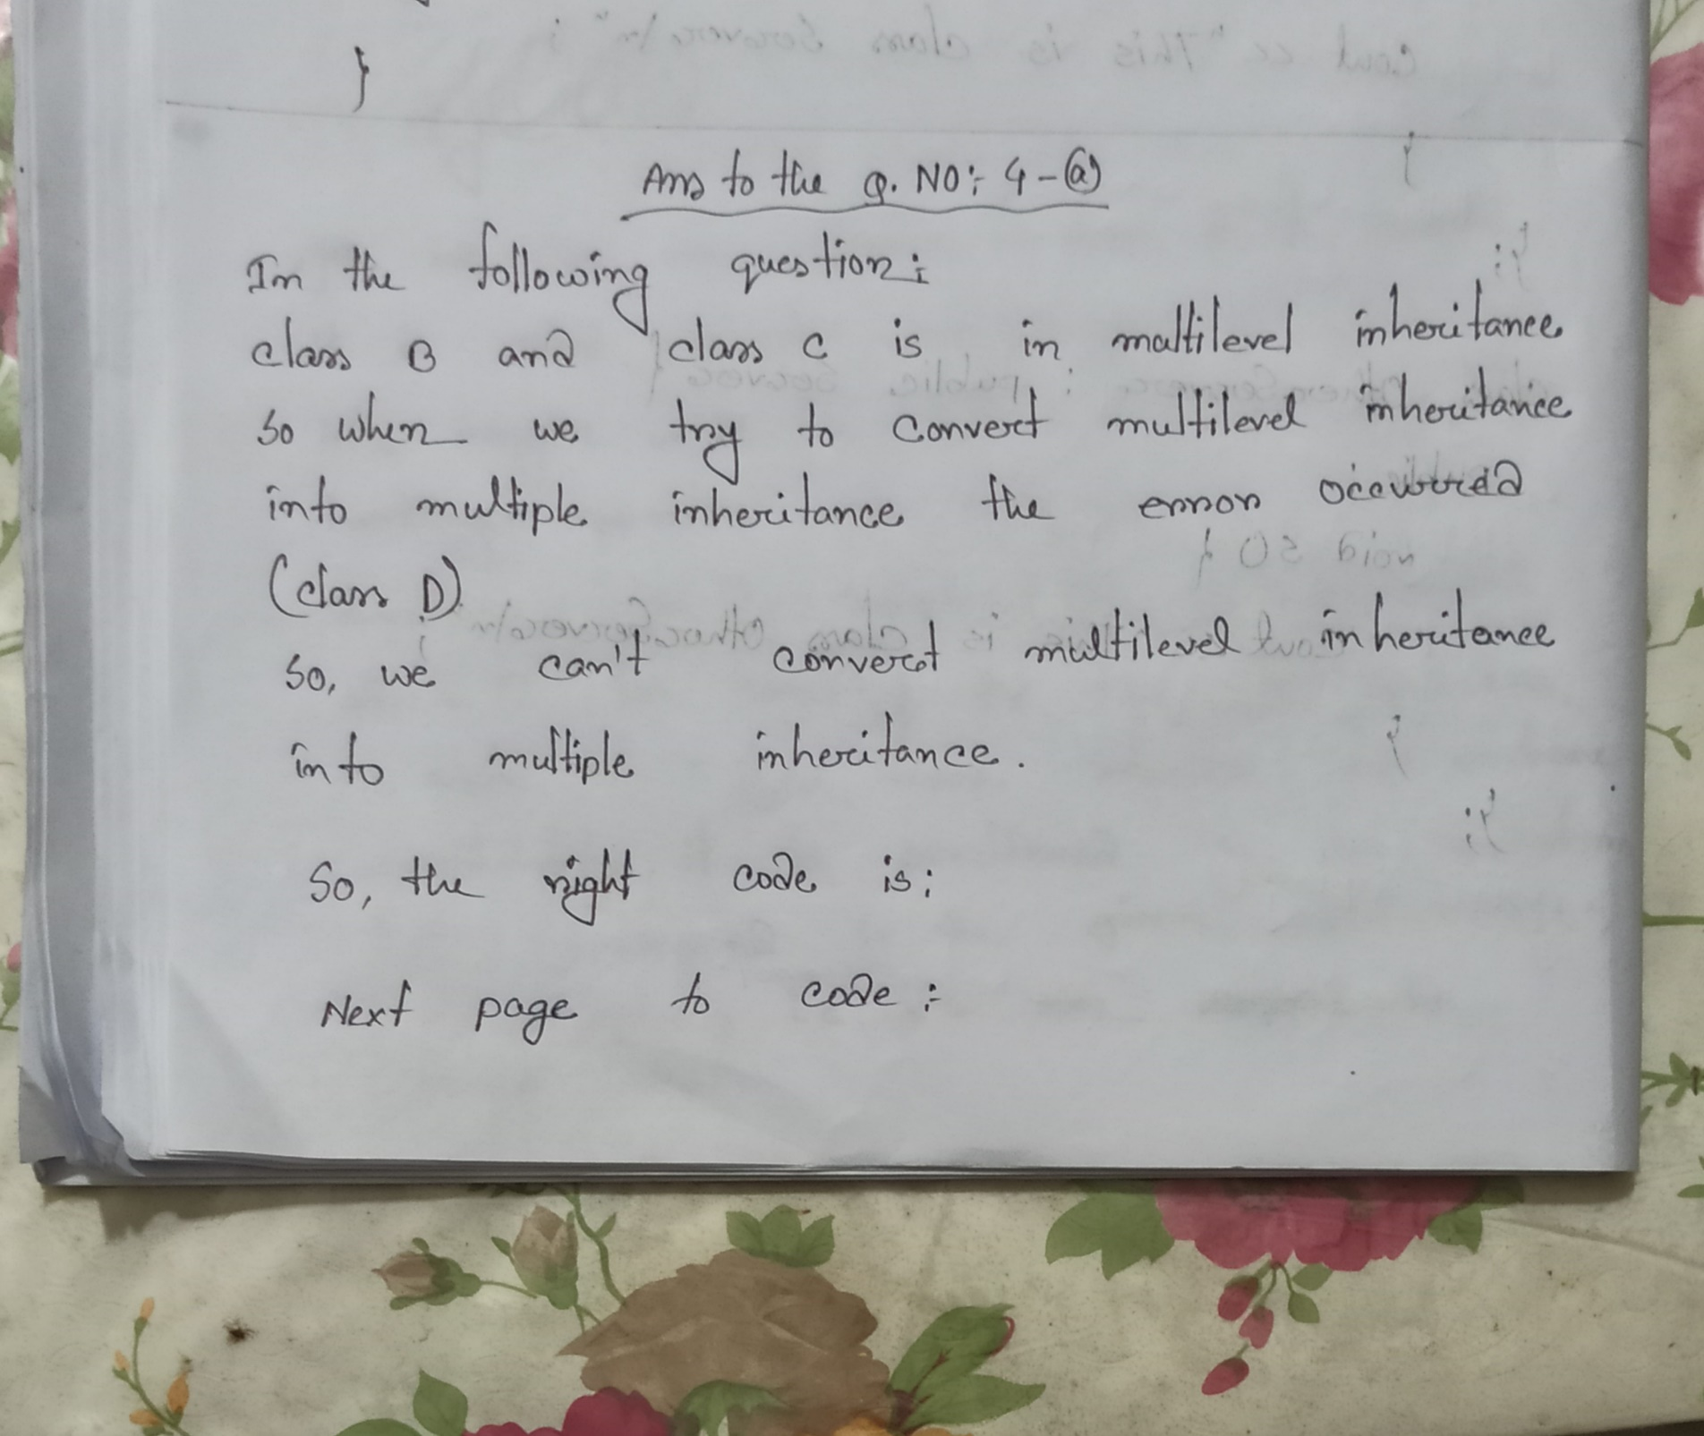

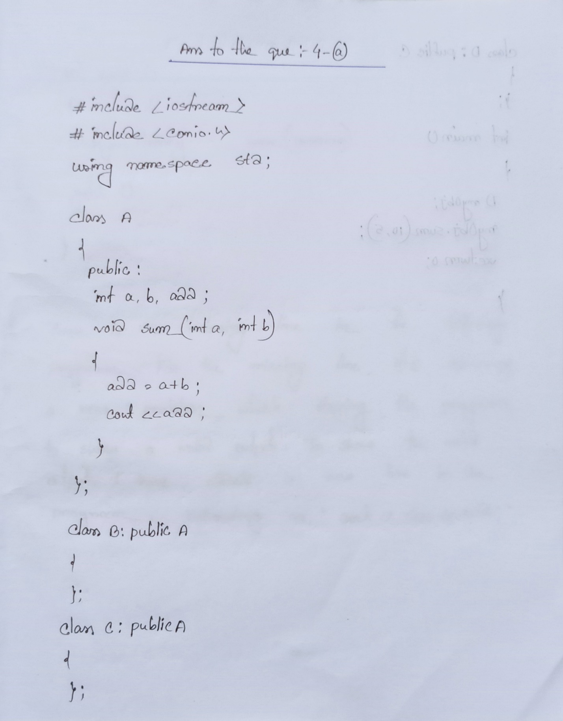

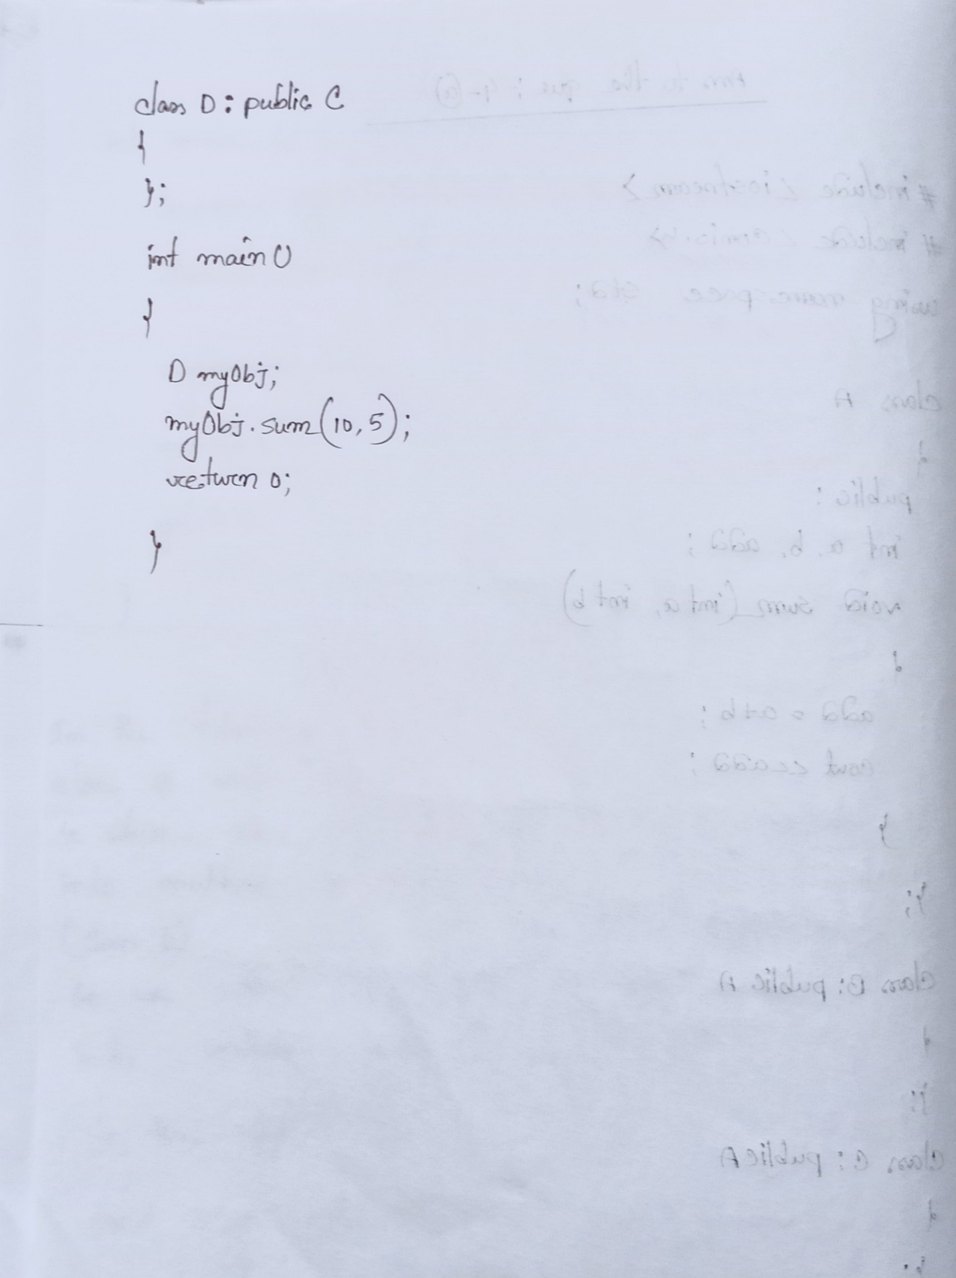

Ans To The Que No : 04-(b)

